(PLEASE ALSO SEE ATTACHED WORD FILE ‘MEMO TO ES HOA BOARD’ and supplemental attached files if content isn’t apparent below)

Sept. 3, 2017

TO: El Shaddai II & III HOA Board
FROM: Patrick Greany
Cc: Kraig & Leslie Adams

RE: INFORMATION FOR EL SHADDAI II&III BOARD RE: HICKORY RIDGE RD. IMPROVEMENTS

El Shaddai Board –

This is to request the El Shaddai II & III HOA Board’s permission to add gravel to Hickory Ridge Rd. at my expense and no expense to El Shaddai in order to improve access to my Whispering Springs Lot. See illustration below and as attached file.

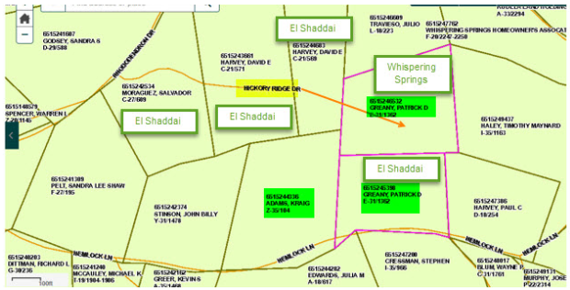

The reason for this request is to preserve the road’s integrity and provide better access for a well drilling rig to be brought onto my Whispering Springs lot. This lot is otherwise not provided with water by the Whispering Springs Association. The well will be used to also provide water to my cabin in El Shaddai and the cabin owned by Kraig and Leslie Adams. I have oral permission from Whispering Springs water manager, Gary Carver and in accordance with Whispering Springs covenants, to drill on my WS lot. I have obtained an official permit to install a well on this lot, issued by Mr. Harold Faircloth, of the Macon County Public Health Department (see copy below and as attached file).

As I discussed the road gravel improvements with Tom McClean today, he mentioned requesting approval from the HOA board and concerns with potential cross-contamination to the El Shaddai water system. There isn’t any chance of cross-contamination of the El Shaddai water system from the well water because (1) there is already a back-flow preventer on my system and (2) I will also install a meter on the incoming pipe from El Shaddai water. The meter has an integral back flow preventer.

According to the El Shaddai II & III and Whispering Springs Deed Restrictions, they specifically allow property owners to drill wells as long as they meet the following conditions: “Each lot owner shall have the right and option to drill a well on his or her lot, and shall not be required to use the community water system, provided, however that no well shall be drilled within 50 feet of the boundary lines of any lot.” (See p. 8 of Declaration of Restrictions, etc.). Based on the Macon Co. permit diagram attached, the intended drilling site is well beyond the 50’ property line. The property was surveyed by Bruce Black last year, so the property line designation shown in the permit is current.

I will be joined in this effort by Kraig & Leslie Adams, who own the adjoining cabin next to my cabin and they are supporting the effort and will share the use of the well water. The use of well water would be the primary source of water for both properties and will reduce stress on the El Shaddai system. We both fully intend to continue abiding by the El Shaddai covenants and will pay the full amount of our HOA dues covering water and road use and infrastructure maintenance along with any future assessments needed to enhance the El Shaddai water system. Adding this well should not have any negative impacts on the El Shaddai system, either financially or otherwise. Instead, it will lessen the stress on the El Shaddai water system at no cost to El Shaddai.

Lastly, any significant damage to the Rhododendron Rd. by the well rig equipment would be repaired by me and Kraig Adams; as would be the same if any construction equipment were to damage our main roads in our community if required by a resident for improvements to their property.

We would like to have an approval by Wednesday September 6th if possible and appreciate your consideration and prompt approval of this request.

Thank you for your cooperation.

Patrick Greany
pgreany@comcast.net
850-528-6803 (cell / text)

